**Meeting Minutes**

**Date: 10 Oct, 2023 Time: 13:05 pm**

**Project Title: Tweetify**

**Members:**

|  |  |  |
| --- | --- | --- |
| **Registration No** | **Name** | **Attendance/ Remark** |
| **2021-CS-190** | **Abdul Mateen** | **Present** |
| **2021-CS-205** | **Alishba Javeed** | **Present** |

**Type of Meeting: Physical**

**Location: Lab 1, CS Department UET Lahore**

**Agenda:**

* **Project Review**
* **Front End Design Evaluation**
* **Database Implementation review**

**Discussion or Feedback**

Discuss the database implementation with client. Front End Design Explained to Client.

**Signature:**

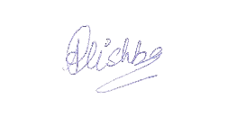

Owner

Alishba Javeed

Developer

Abdul Mateen